Casio to Release New PRO TREK with 200-Meter Water Resistance
Featuring Triple Sensor, Ver. 3 for High-Precision Readings of Compass Bearing, Barometric Pressure/Altitude, and Temperature, An Excellent Watch for Outdoor Water Activities

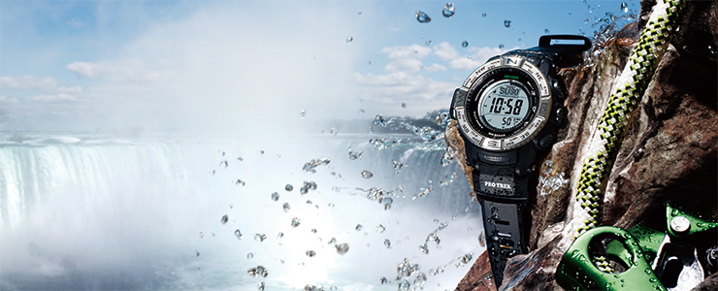
PRW-3500-1
BASEL, March 18, 2015 — Casio Computer Co., Ltd., announced today a new addition to the PRO TREK line of outdoor watches. The new PRW-3500 is the first PRO TREK watch with both water resistance to 200 meters and Triple Sensor, Ver. 3, Casio’s technology for delivering highly precise readings of compass bearing, barometric pressure/altitude, and temperature.
The PRO TREK series of outdoor watches leverages cutting-edge sensor technology to measure different types of outdoor data. The existing model PRW-3000 provides numerical sensor data using its digital display, and the PRW-6000 has an analog display that conveys the information via hand position like a gauge. Both existing models are equipped with the latest Triple Sensor, Ver. 3, and have become popular with mountain climbers and trekking enthusiasts.
Based on the PRW-3000, which has a digital display and is water resistant to 100 meters, the new PRW-3500 will be the firstPRO TREK model to feature both Triple Sensor, Ver. 3 and 200-meter water resistance. Thanks to the high level of water protection, the new model can be worn with confidence during outdoor water activities such as fishing, kayaking, and river rafting.
Designed for a wide variety of outdoor scenes, the PRW-3500 is easy to operate even while wearing gloves, thanks to its large buttons with non-slip surfaces and a register ring that has been shaped for easy gripping with the fingers. The watch lets the user effortlessly check— and even record—all the needed information on outdoor conditions.
The new model also comes with all the usual PRO TREK features such as an atmospheric pressure tendency alarm that notifies the wearer of sudden swings in atmospheric pressure, the Tough Solar power system that charges the watch even in dim light, a full auto LED backlight that illuminates in the dark with a tilt of the wrist, and Multi Band 6 technology for receiving time-calibration signals transmitted from six stations around the world. With standard features like these, the new PRW-3500 can be worn with complete confidence.

Model | Bezel Color | Band | Surface coating
PRW-3500-1 | Silver | Resin | -
PRW-3500Y-1 | Blue |  | IP Processing
PRW-3500Y-4 | Orange
PRW-3500T-7 | Black | Titanium

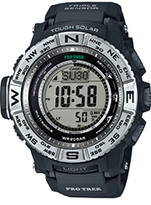  PRW-3500-1 | 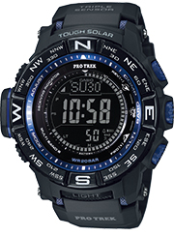  PRW-3500Y-1
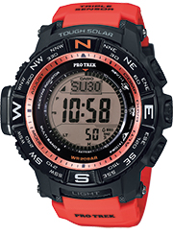  PRW-3500Y-4 | 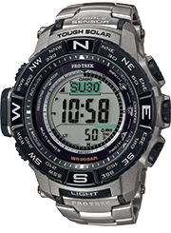  PRW-3500T-7
Specifications
Construction | Low-temperature resistance (–10°C /14°F)
Water Resistance | 200 meters
Radio Frequencies | 77.5 kHz (DCF77: Germany); 60 kHz (MSF: UK); 60 kHz (WWVB: USA); 40 kHz (JJY: Fukushima, Japan) / 60 kHz (JJY: Kyushu, Japan); 68.5 kHz (BPC: China)
Radio Wave Reception | Automatic reception up to six times a day (in China, up to five times a day); manual reception
Compass | 16 points; measuring range (0°- 359°); 60 seconds continuous measurement; 4 bearing graphic display (North, South, East, West); bearing memory (angle and graphic); magnetic bearing deviation correction function; bearing correction function
Barometer | Display range: 260 hPa – 1,100 hPa (7.65 to 32.45 inHg); atmospheric pressure differential graphic; atmospheric pressure tendency graph (past 42 hours)
Altimeter | Display range: -700m – 10,000m (-2,300 to 32,800 ft.); able to record the last 14 altitude measurements with the month, date and time (as well as memory for the highest/lowest altitude, calculated ascent/descent altitude, and cumulative ascent/descent altitude); altitude tendency graph display; measurement interval setting (every 5 seconds / every 2 minutes); altitude difference measurement (±3000m)
Thermometer | Display range: -10°C to 60°C (14ºF to 140ºF)
World Time | 31 time zones (48 cities ＋ Coordinated Universal Time); city name display; daylight saving on/off
Stopwatch | 1/10 second; measuring capacity: 1000 hours
Countdown Timer | Measuring unit: 1 second (maximum 24 hours)
Alarm | 5 independent daily alarms; hourly time signal
Others | Full auto-calendar (until 2099); 12/24-hour format; sunrise/sunset time display; battery level indicator; button operation tone on/off; full auto LED backlight (Super Illuminator) with afterglow; selectable illumination duration: 1.5 or 3.0 seconds
Power Source | Tough Solar power system (high-capacity solar-charging system)
Continuous Operation | About 23 months with the power-saving function*1 ON after full charge  *1 Display shuts off after a certain period in a dark location
Size of Case | 56.9 × 53.4 × 14.5 mm (PRW-3500)  56.9 × 53.4 × 14.8 mm (PRW-3500Y/3500T)
Total Weight | Approx. 89g (PRW-3500)  Approx. 90g (PRW-3500Y)  Approx. 128g (PRW-3500T)

